
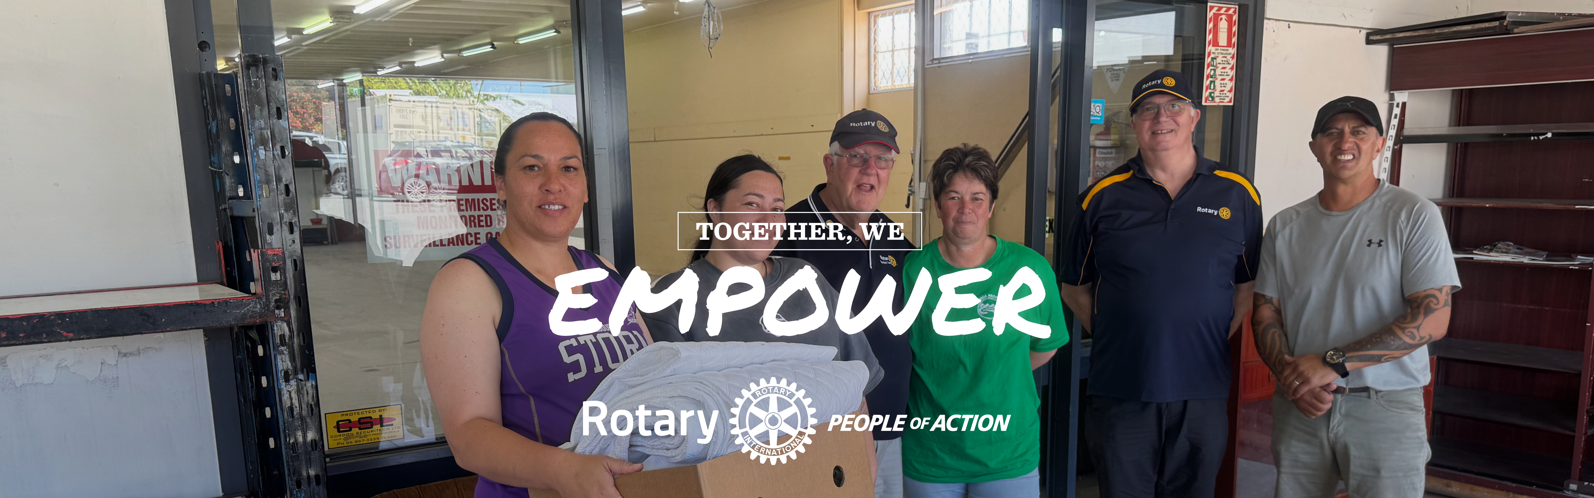
Message from District Governor Nick
Kia ora, fellow Rotarians,
As we approach the final months of this Rotary year, I am filled with immense pride in all that we have accomplished together. Our journey through the Rotary Zone 8 (South Pacific) Regionalisation Pilot continues to inspire change, fostering a stronger, more connected Rotary that empowers clubs and enhances our impact.
This pilot is not just about structural adjustments, it’s about creating a Rotary that is fit for the future, where collaboration and innovation lead the way. However, this does not happen by itself. It needs clubs to engage with the process.
Another exciting milestone awaits us next month, the combined Districts 9930 and 9920 Conference in Rotorua! This joint event is a testament to the power of partnerships, bringing together Rotarians from across the New Zealand to share ideas, celebrate achievements, and be inspired by incredible speakers. If you haven’t already registered, I encourage you to do so—this is a conference you won’t want to miss!
Looking further ahead, the Rotary International Convention in Calgary is just around the corner in June. This global gathering of Rotarians is an extraordinary opportunity to connect with fellow members from around the world, exchange ideas, and be motivated by Rotary’s international reach. For those attending, I hope you take full advantage of this incredible experience and return with fresh perspectives to share with your clubs.
Thank you for your dedication, enthusiasm, and commitment to making our communities and the world a better place.
Let’s finish this Rotary year strong!
DG Nick & Maria Dangerfield

ShelterBox is sending a team to Thailand



Myanmar and Thailand have been struck by a devastating 7.7 magnitude earthquake, causing widespread destruction. Tremors were felt as far as China when the earthquake hit central Myanmar.
The full extent of damage is as yet unknown, but early reports show significant destruction across both Myanmar and Thailand.

ShelterBox is sending a team to Thailand.
This crisis and response will draw heavily on already stretched resources.
DONATE directly & securely

Myanmar’s authorities have made a rare request for international humanitarian aid and declared a state of emergency across six regions. Similarly, Thai authorities have declared a state of emergency in Bangkok, where buildings are not
designed to withstand such shocks. Vulnerable people in these countries will certainly be rendered homeless and in need of emergency shelter.
Our ShelterBox team in Thailand will coordinate efforts and determine how best to support those affected. Your support is crucial in making this response possible.
We have experience supporting people in Myanmar and Thailand.
This is a huge humanitarian crisis. We are grateful for your consideration and any support you can lend.
Brent Eddy, Chair, ShelterBox New Zealand Charitable Trust
brenteddy@shelterbox.org.nz

The President-Elect Learning & Development Seminar (PELDS)

This is a crucial training event designed to prepare incoming Rotary Club Presidents for their leadership year
At PELDS, President-Elects connect with experienced leaders, exchange ideas with fellow incoming presidents, and gain inspiration for leading their clubs with confidence.
It will cover a program developed by the regional council so that Rotary can improve its consistency of message
PELDS is being held on 5 April at South Waikato Sport and Event Centre
9:00 am – 4:00 pm

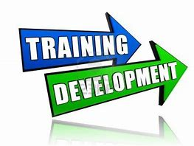

Save the Date – District Training Assembly

📅 Saturday, June 7, 2025
📍 Tauhara College, Taupo

Join us for the District Training Assembly, a vital opportunity for club leaders and members to prepare for the year ahead. Gain insights, share ideas, and connect with fellow Rotarians as we strengthen our clubs and communities.
More details to come—stay tuned!

Communicating our “ImPact” in your Club or Community



As we said in our last newsletter promoting Rotary activities on Facebook is a powerful way to amplify your impact and connect with your community. I have been saying in my message to clubs not only do we need to work on the product we are offering with a focus on the impact that we are making but we also need to promote that work
With millions of users engaging daily, in Facebook and other social media platforms you have an accessible way to promote and share your club's projects, successes, and upcoming events with a wider audience. It not only raises awareness of Rotary's mission but also attracts potential members and supporters who resonate with your cause.
To post your stories on the district Facebook page contact:
Janine Branson: bjanine@xtra.co.nz or
IPDG Bill Robinson: billrobinson701@gmail.com

Musical Garden in Napier
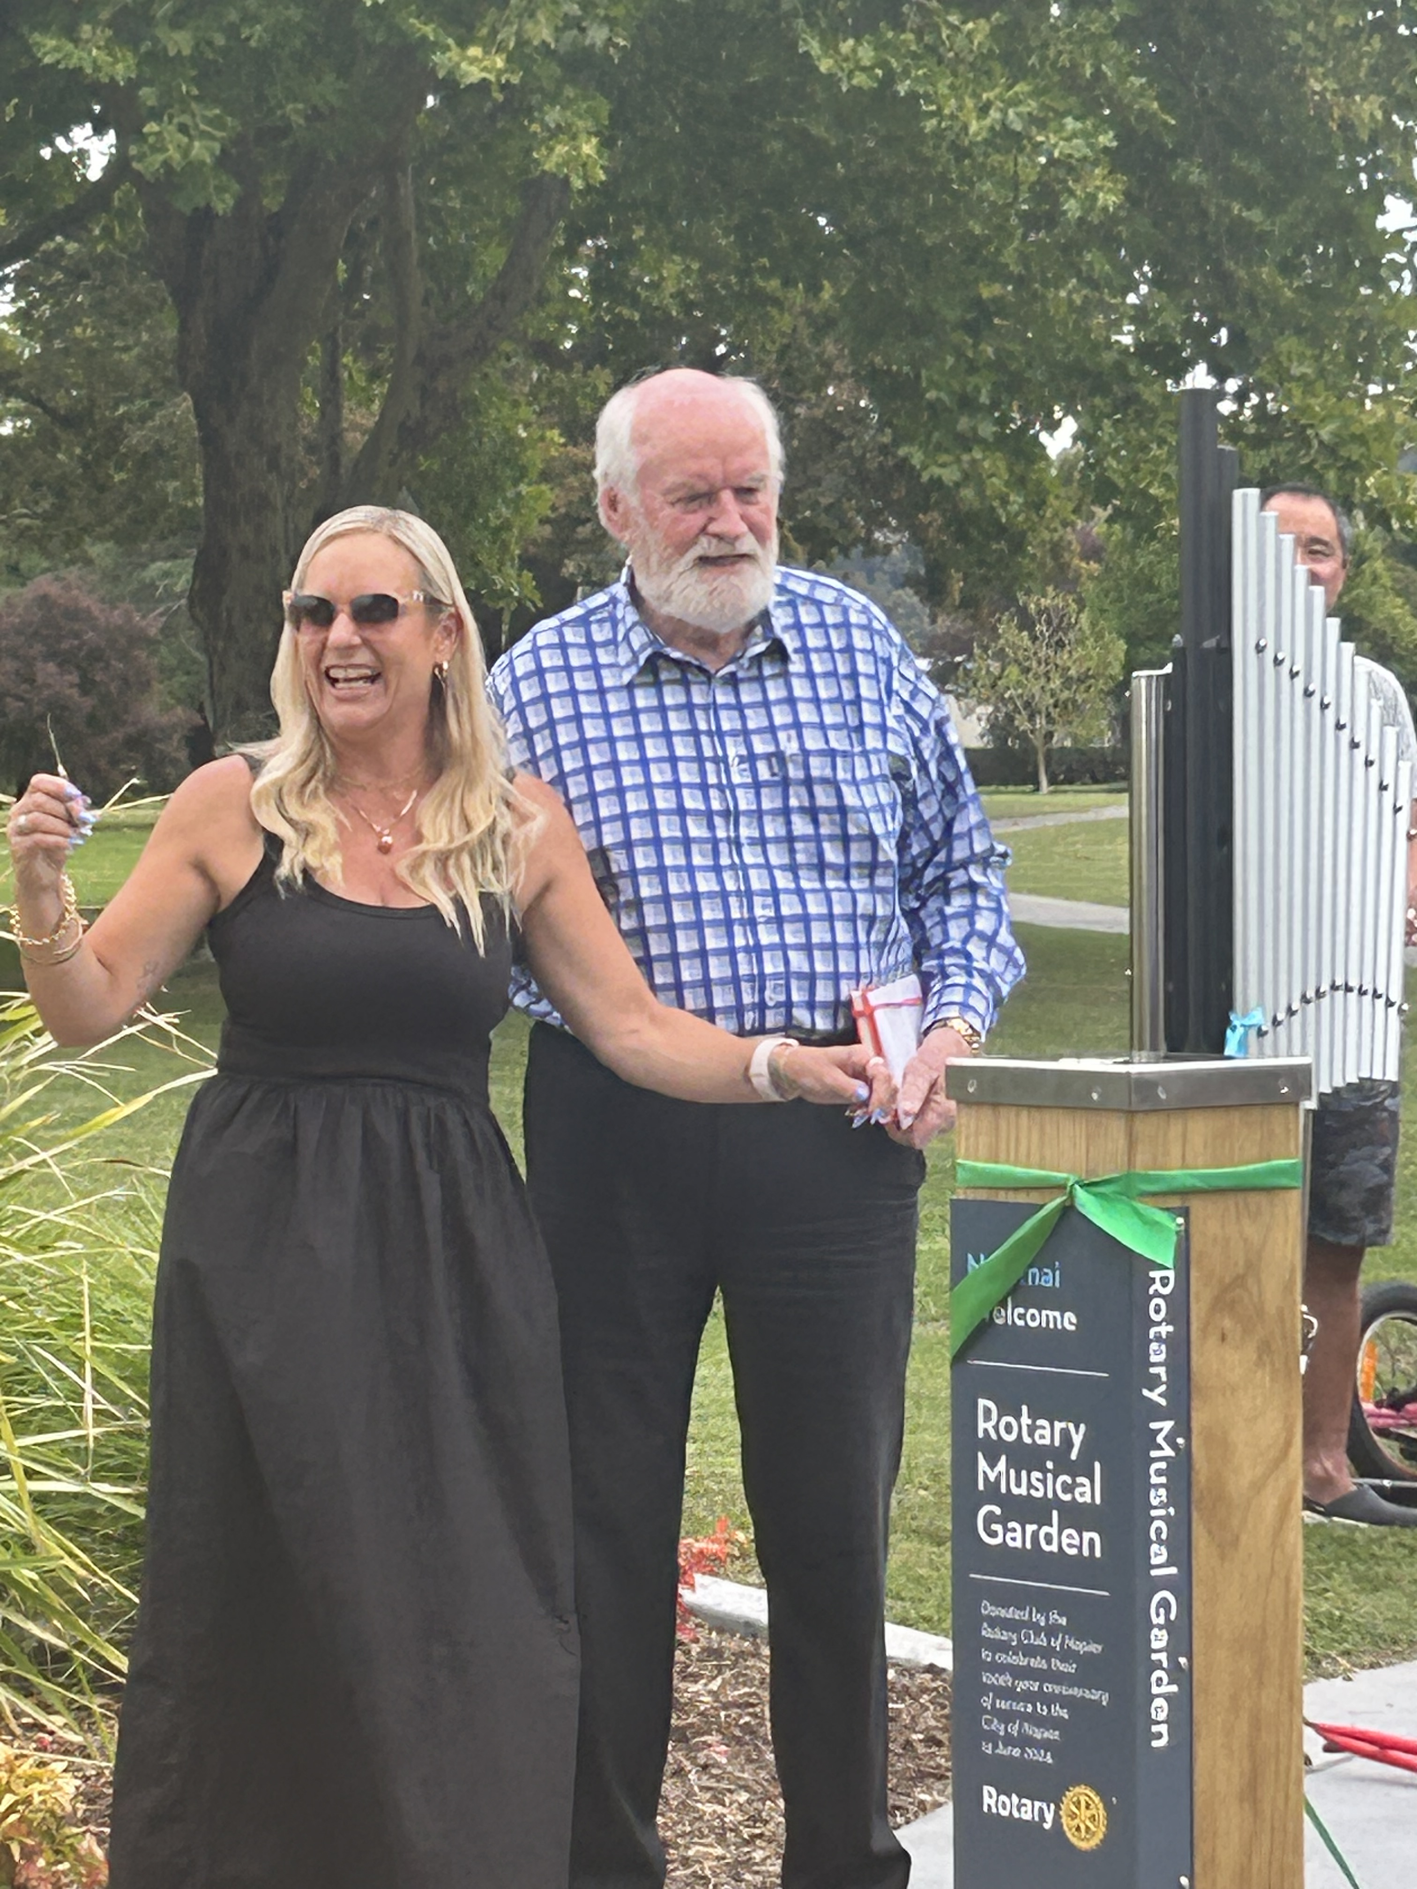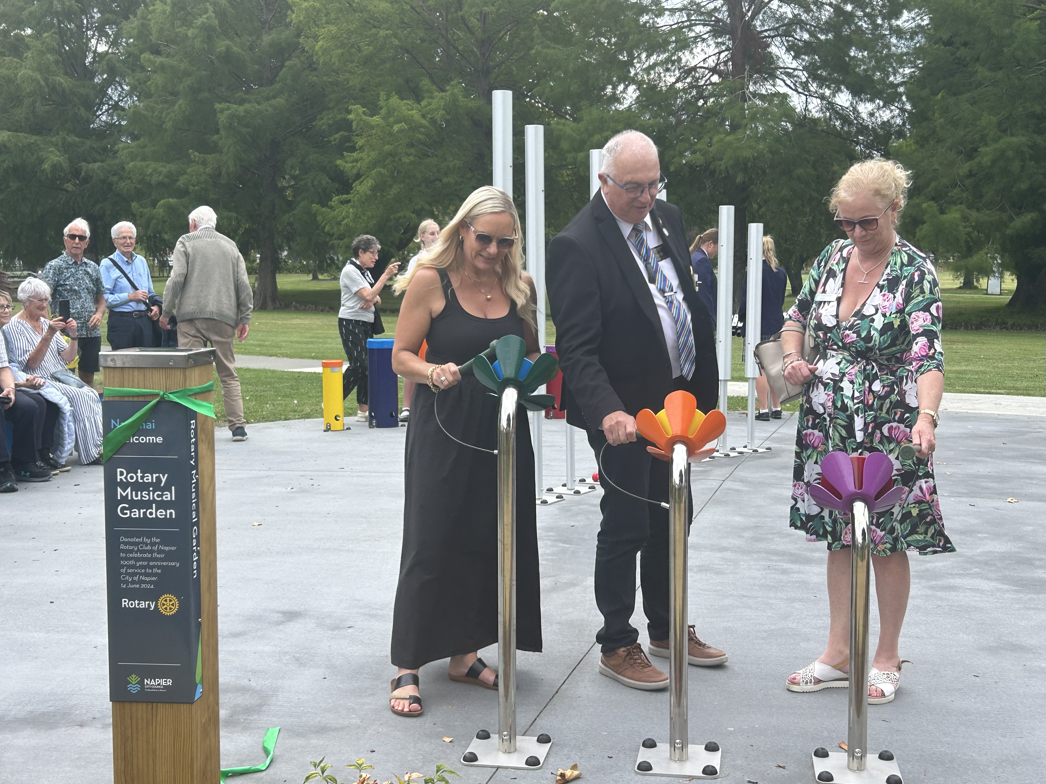

Maria and I were excited to celebrate the official opening of the Rotary Musical Garden at Anderson Park, Napier! A centaury project for the Napier Club (who are now part of the Napier Ahuriri Club) This wonderful project, made possible through the Rotary clubs and community supporters. It provides a creative and interactive space for people of all ages to enjoy the joy of music in a beautiful outdoor setting.
A fantastic example of Rotary in action, this initiative enhances our community, promotes inclusivity, and brings people together through the universal language of music. Thank you to everyone involved in making this vision a reality!

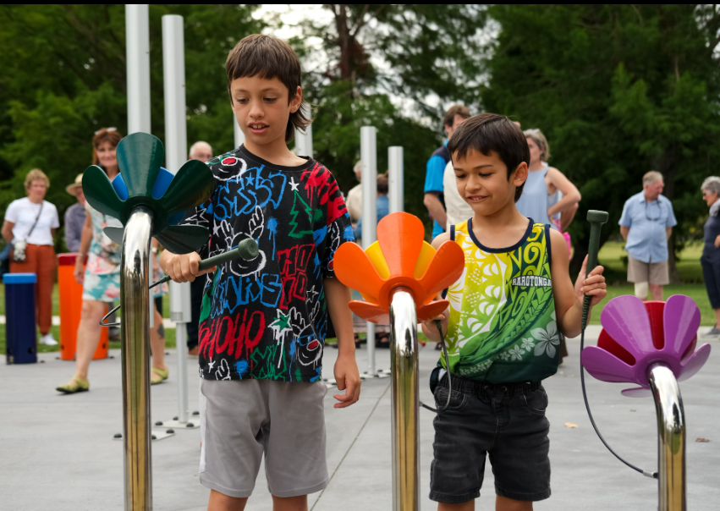

Opportunity to serve

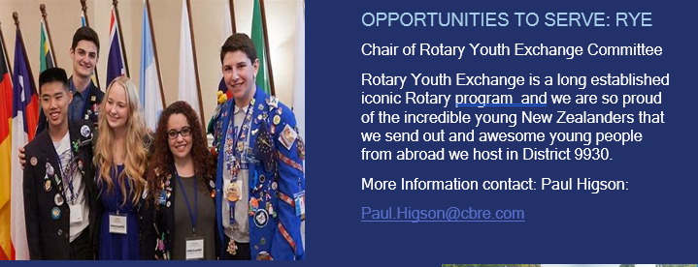

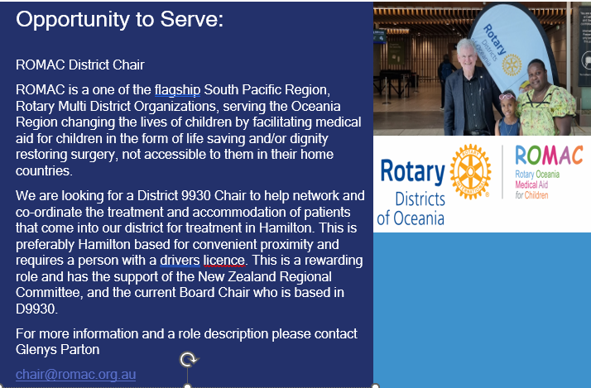

Think AND BE mE Workshop Funding

As you would know from club visits my project this year is support the “Think and Be Me” project which about creating emotional resilience in our primary age school children.
As our part of public outreach for our District Conference we now have 70 teachers registered for the “Think and Be” workshop to learn about the program, as well as giving them the resources help deliver this in their classroom.
CHALLENGE TO ALL CLUBS AND OR MEMBERS
Funding such an initiative is always challenging and if every club in the district could consider donating $200 (or more) it would help ensure that we can make a significant impact in the lives of young people.
A separate email will be sent to Club Presidents and Secretaries with this request.
Want to know more? Visit this webpage below, or give us a call
Nick: 0212736476 Maria: 0273488299
Website link: Better Together - Rotorua – Think and Be Me
Please make your donation to the District Conference Bank account:
03-1552-0121120-003
Reference: think be me wk
DG Nick Dangerfield

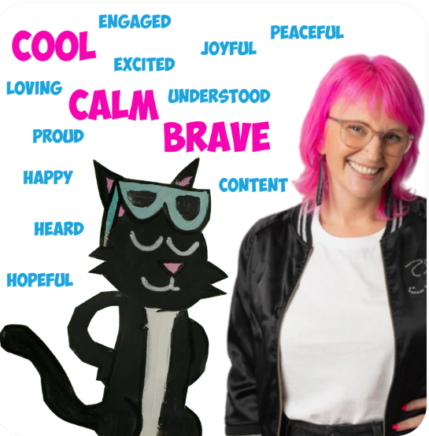



Musical Garden in Napier

Maria RYLA (Rotary Youth Leadership AwarDS)

Rotary Youth Leadership Awards
Our regional RYLA is held at Epworth Recreation Centre, on Lake Karapiro in April each year.
RYLA 2025 will be from Saturday 12th (9.30 am) until Thursday 17th (9 pm) of April.
For more information:
https://rotary9930.org/page/youth-ryla

RYPEN (Rotary Youth Program for Enrichment)

Teenagers today benefit greatly from opportunities to develop life skills and motivation to help them cope with the challenges of a very competitive future. Students have pressure to perform academically: their results are the benchmark of success. However, other skills are needed for the next stage of a student's growth, be that further education or the workplace.
RYPEN is aimed at year 10 students, who have shown qualities of decency, courage, persistence, sincerity, leadership and application in everyday life, and who deserve further development and guidance.
There are various RYPEN camp held across the district during the Rotary year, and they make a huge difference to the lives of students who attend them.
Our next RYPEN Year 10 Weekend Camp is being held at Lakewood Lodge at Glen Murray 9-11th May 2025.
For further information about RYPEN please contact:
District Chair Rowan Anderson (rowan.anderson.nz@gmail.com)

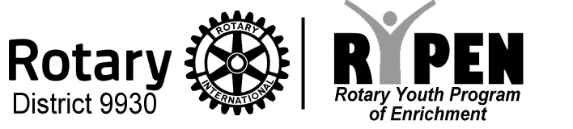

je made possible through the Rotary clubs and community supporters. It provides a creative and


Club Membership Champions

Having a Rotary Club Membership Champion can be a game-changer for any club.
This dedicated individual focuses on driving membership growth and retention by actively engaging with current and potential members. It would be helpful (but necessary) to have a Membership Champion, who also has participated in Rotary program who make connections to other Alumni.
The Champion also keeps a pulse on member satisfaction, organizing meaningful activities and addressing any concerns to foster long-term involvement.
If want help with membership issues, please contact:
Johnny Dryden
johnnydryden@xtra.co.nz

The Rotary Specialist Network

Under the Rotary Zone 8 (South Pacific) Regionalisation Pilot, the Rotary Specialist Network is a valuable resource to help your club achieve its goals more effectively.

This network connects clubs with experienced Rotarians who bring expertise in areas such as membership growth, project development, public image, and fundraising.

By tapping into this pool of knowledge, your club can gain fresh insights, access best practices, and receive tailored support to overcome challenges and maximize impact.

Whether you need guidance on strategic planning, applying for grants, or increasing community engagement, the Rotary Specialist Network is there to support you.

Make the most of this initiative to strengthen your club and enhance the good work you do!

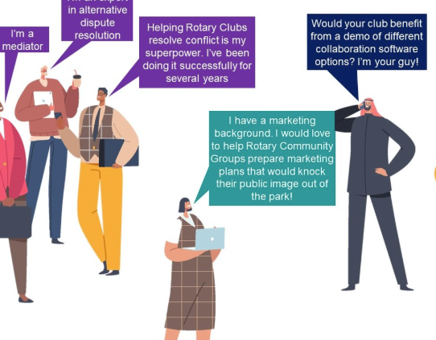

You can find a link to the specialist network on the district website:
https://rotary9930.org/

Communities and Community Leaders

Under the Rotary Zone 8 (South Pacific) Regionalisation Pilot, communities and community leaders play a vital role in shaping the future of Rotary in our region.
The pilot aims to strengthen Rotary’s impact by empowering local clubs to collaborate more effectively, engage with their communities, and streamline governance.
Community leaders—both within and outside of Rotary—are essential partners in this process, bringing diverse perspectives and expertise to help address local challenges and opportunities.
By fostering stronger connections between Rotary clubs and community stakeholders, the pilot enhances our ability to create lasting impactful change, ensuring that Rotary remains a dynamic and influential force in across the South Pacific zone.

